所有字体保留原来的格式。



BLISS改为KEYLING ， Italian restaurant 改为 flavor ，

home 不变， menu改为 products， reservation改为 about， blog改为 careers，

contacts不变 （格式都一样）

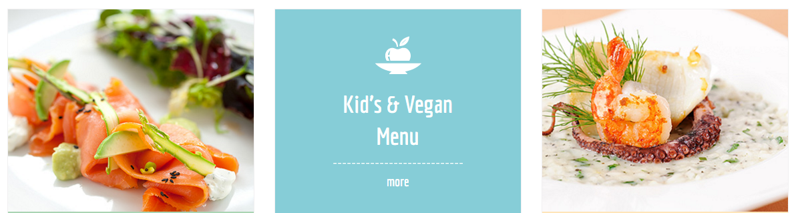

图1改为图1a， 中间苹果果盘不改把kid‘s & vegan Menu改为 Food Flavor

图2改为图2a。 more功能删除



把左边的traditional Cuisine改为 [Food Additives](http://www.hbkq.cn/En/products.asp?ParentID1=61)叉子保留， 把图3改为图3a，

把happy hours & offers 改为 drink flavor 。 more功能删除

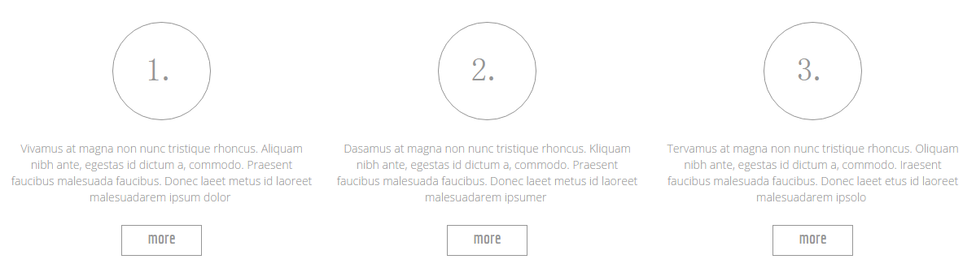

保留格式。1. 的内容改为：**Food additives** are substances added to food to preserve flavor or enhance its taste **and appearance. Some additives have been used for centuries for example, preserving food by**[**pickling**](https://en.wikipedia.org/wiki/Pickling)**(with**[**vinegar**](https://en.wikipedia.org/wiki/Vinegar)**),**[**salting**](https://en.wikipedia.org/wiki/Salt)**, as with**[**bacon**](https://en.wikipedia.org/wiki/Bacon)**.**

**2.的内容改为：**Food Flavor is the sensory impression of [food](https://en.wikipedia.org/wiki/Food) or other [substance](https://en.wikipedia.org/wiki/Chemical_substance), and is determined primarily by the chemical senses of [taste](https://en.wikipedia.org/wiki/Taste" \o "Taste)and [smell](https://en.wikipedia.org/wiki/Olfaction). The "[trigeminal senses](https://en.wikipedia.org/wiki/Trigeminal_nerve)", which detect chemical [irritants](https://en.wikipedia.org/wiki/Irritation) in the [mouth](https://en.wikipedia.org/wiki/Mouth) and [throat](https://en.wikipedia.org/wiki/Throat) as well as temperature and texture, are also important to the overall [Gestalt](https://en.wikipedia.org/wiki/Gestalt_psychology) of flavor perception.

3.的内容改为：Drink Flavor is a [dynamic list](https://en.wikipedia.org/wiki/Wikipedia:WikiProject_Lists#Incomplete_lists) and may never be able to satisfy particular standards for completeness. You can help by [expanding it](https://en.wikipedia.org/w/index.php?title=List_of_soft_drink_flavors&action=edit) with [reliably sourced](https://en.wikipedia.org/wiki/Wikipedia:Identifying_reliable_sources) entries*.*

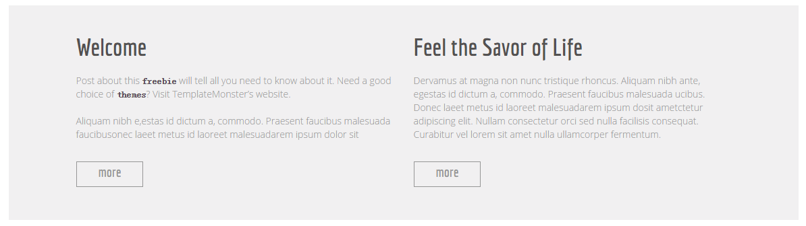

Welcome 改为 Peacock Flavor，下面的内容改为，  "Peacock flavor" is the birthplace of the national flavor industry, and is a microcosm of the history of China’s Flavors and Fragrances industry. Peacock brand is known as the originator of the domestic flavor industry.

Feel the Savor of Life 改为：Enterprise Culture，下面内容改为：Corporate Vision: striving to be the first (or No.1) Corporate values: Market oriented, customer first, and to realize the common development between the company and employees. Corporate spirit: Innovative, practical, loyalty, cooperation

More 的功能取消。

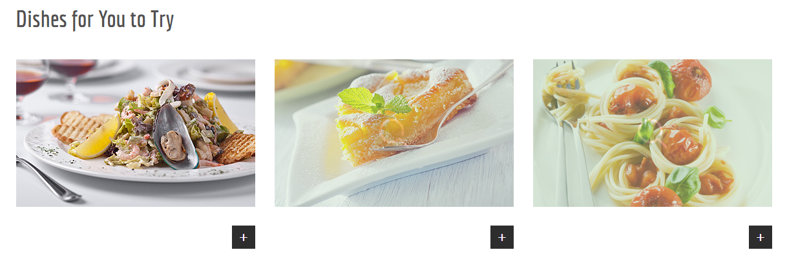

Dishes for you to try 改为 Technology Center 下面再加一段文字：

Based on company’s only State-authorized corporate technical center and the national post-graduate research workstation in the industry, together with sharing of the research information and achievements from the overseas organizations under Huabao International as well as the long-term and friendly partnership with national leading universities, colleges and research institutes, we have made achievements in flavor and fragrance release technology, enzymatic modification and other fundamental research fields, which help us maintain our industry leadership.

图4,5,6 分别改为 图4a，5a，6a的图



-----

Testimonials改为 Quality （把more testimonials）删除

内容改为： Flavor Foods is to satisfy the needs of our customers and partners, through professional, ethical and continuous improvement actions by offering certified products and high market recognition.

---

What’s news 保持：

11 june改为 16 fev，内容改为： keyling Flavour held the third meeting of process reengineering work in the conference room.On the basis of two previous meetings, this meeting did a detailed study of process ,ensuring the rationality and effectiveness of business processes, avoiding duplication and non-standard process operations.

15 apr 改为 18 APR，内容改为：In order to integrate into the keyling family and give a sense of belonging for the new employees, the Ministry of Personnel held a tea party. About fifty people attended this meeting.

---

Opening Hours 改为：Objective，下面黑色条分别改为：Innovative, practical, cooperation

第二页：products

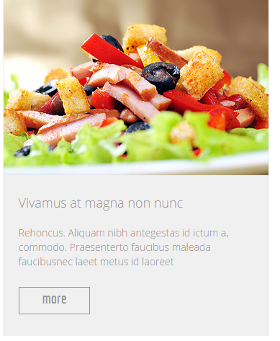-图7改为图7a，

-把标题改为：Ice Cream Flavors

-文章改为：Ice cream is a frozen dessert usually made from dairy products, such as milk and cream and often combined with fruits or other ingredients and flavors. Most varieties contain sugar, although some are made with other sweeteners.

-More键保留

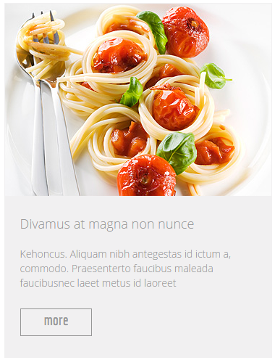

-图8改为图8a

-把标题改为：Sweet Flavors

-文章改为：Sensient provides industry-leading flavor systems across the global sweet market. Our extensive flavor portfolio includes a variety of solutions that enable us to create exceptional flavor innovation to help you drive growth in various segments.

-More键保留

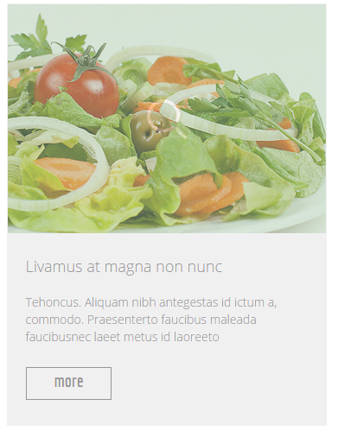

-图9改为图9a

-把标题改为：Cake Flavors

-文章改为：We provide a unique (and long) list of flavors to choose from. All of our cakes are iced in a thick layer of our buttercream, which is made in the Swiss tradition

-More键保留

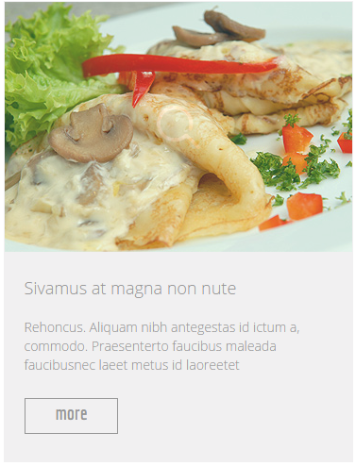

-图10改为图10a，

-把标题改为：Spicy Flavors

-文章改为：Spices are seasonings obtained from the bark, buds, fruit or flower parts, roots, seeds or stems of various aromatic plants and trees. We will use the word spices to indicate any substance, herb, spice, or vegetable used to flavor foods.

-More键保留

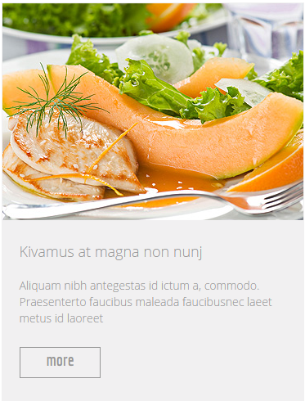

-图11改为图11a，

-把标题改为：Beer Flavors

-文章改为：Crisp beers are lighter, cleaner in flavor, and crisply refreshing. They range in color from straw to amber, have low to medium abvs, and are light to medium in body.

-More键保留

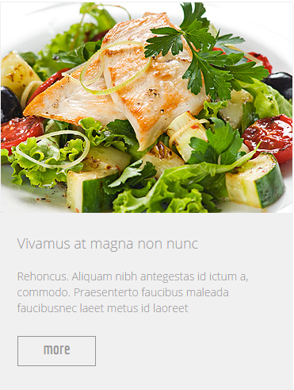

-图12改为图12a，

-把标题改为：Flower Flavors

-文章改为：Flower flavors have been hailed as some of the best flavoring concentrates and extracts you can use for DIY e-juice! These flavors are pure extracts of the actual material, not synthetic blends of unrelated flavor chemicals.

-More键保留

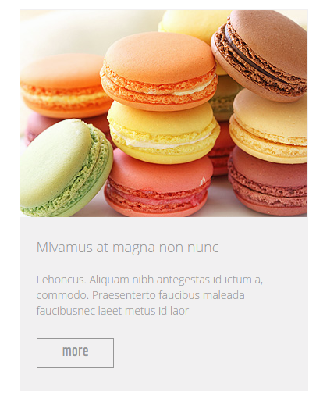

-图13改为图13a，

-把标题改为：Cosmetic Flavors

-文章改为：Cosmetic flavor oils designed for use in lip balms, lip glosses, lipsticks, and edible massage oils. These flavor oils are oil soluble, unsweetened, do not use any nut derived oils, are vegan friendly and cruelty free, and are free of gluten and parabens.

-More键保留

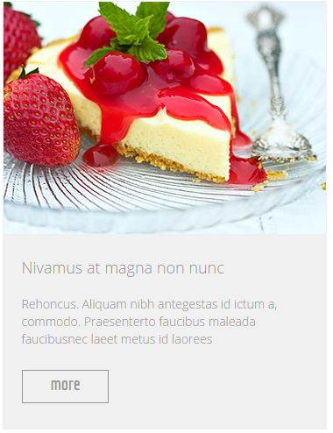

-图14改为图14a，

-把标题改为：Shampoo Flavors

-文章改为：flavored shampoos can instantly turn your shower experience into an aromatherapy pleasure zone! Clarifying shampoos are intended to remove dirt, residue and unwanted oily waxy buildup that has been left in your hair from the use of daily styling products.

-More键保留

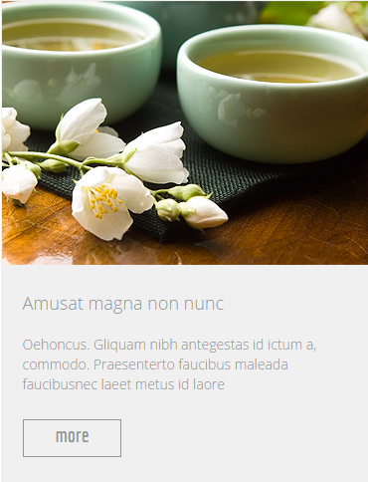

-图15改为图15a，

-把标题改为：Cigarette Flavors

-文章改为：Cigarette flavor has received a great deal of study by cigarette manufacturers but relatively little by academic investigators. The paucity of literature is particularly acute in terms of the importance of flavor in cigarette substitutes, which are used to help people to reduce or quit smoking.

-More键保留



红框里面的保持不变

第三页：About

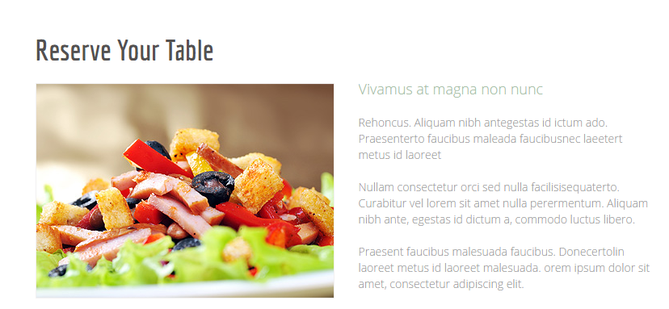

Reserve your table改为 About us：

-把图16改为图16a。

-把绿色标题改为：Keyling Flavor（绿色），以下文章改为：

Shanghai keyling Flavor Co., Ltd. is the origin of flavoring technology in China, as well as a mirror of China’s flavor and fragrance industry. Keyling Flavor well-known brand in flavor industry, as well as famous trademarks and branded products in Shanghai.

Corporate Vision: striving to be the first (or No.1)

Corporate values: Market oriented, customer first, and to realize the common development between the company and employees.

corporate spirit: Innovative, practical, loyalty, cooperation

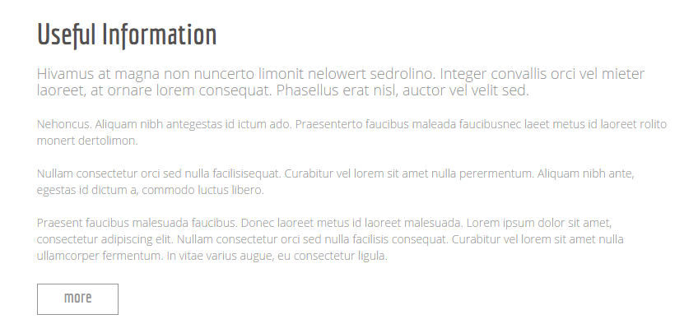

-标题改为： Our Vision

-文章改为：Adhering to the core values of “Customer First”, we work together with hundreds of dealers across China and a number of well-known food industry players inside and outside China. We earnestly offer services of product development, process technology, equipment renovation, industry information and etc. in order to seek for win-win while creating values for our customers.

We aim to establish the flagship in the domestic flavor & fragrance industry, positively boost the technical progress of flavor & fragrance industry in China, continuously create social values with rapid growth, and contribute to ranking Huabao International among international flavor & fragrance powers.

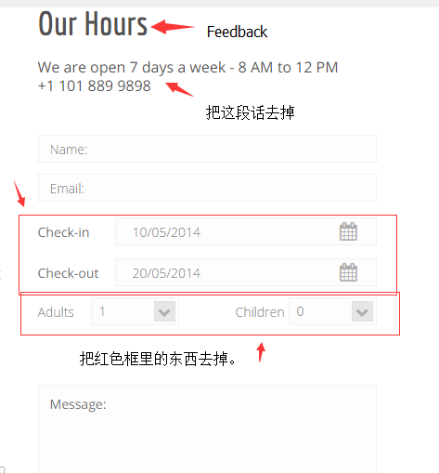

-请按照上面的修改就可以了。把our hours 改为Feedback

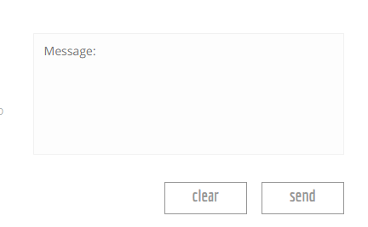 这个不变。

第四页：Careers

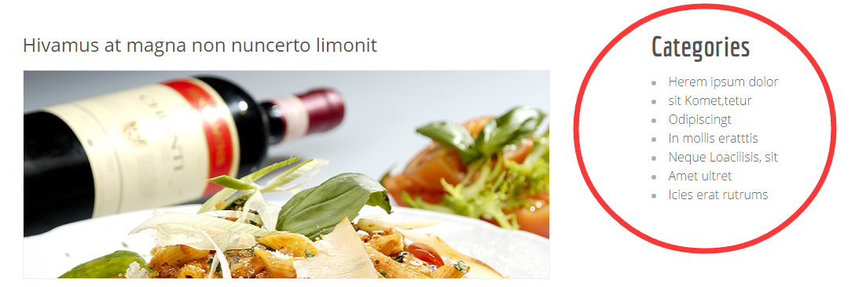

-把hivamus at magna non nuncerto limonit改为：Sincerely invite you to join our company

-图17换成图17a

-把红圈里面的信息改成：

position

. Key Account Sales Director

. Salesperson

. Product Developer

. Project Manager

. Facility Manager

. Food Service Manager

. CFO(Chief Financial Officer)

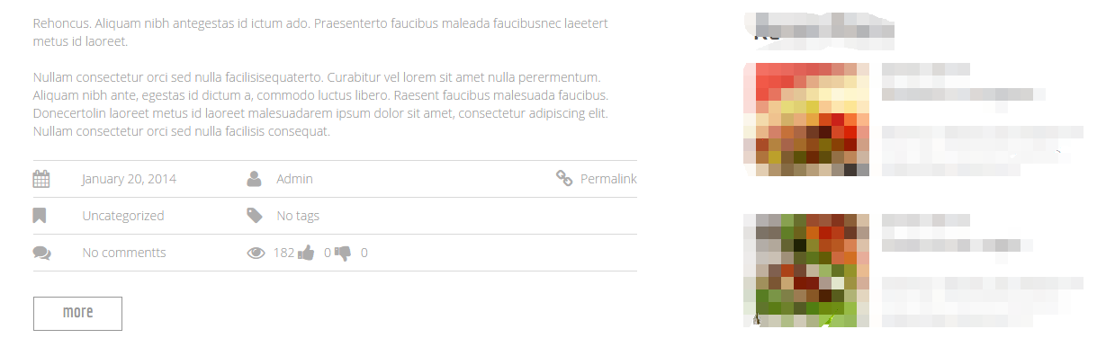

-把上面这段文字改为：

Key Account Sales Director

Requirements:

1、Male, aged 35-45 years old, junior college degree or above, food engineering professional priorities;

2、More than 8 years of food or sales experience in FMCG industry;

3、More than 5 years experience of key account management , successful projects are preferred;

4、More than 3 years experience of team management , extensive team building experience;

5、Able to work under pressure, strong communication skills, negotiation skills，management capacity and coordination.

Responsibilities:

1、Responsible for promotion and communication with key accounts of flavor market;

2、Complete the company issued sales,reimbursement and other indicators of economic assessment

3、Manage reports and daily work of key account department

4、According to the actual market situation,timely adjust marketing strategy

5、Grasp the information of market competitors, raise the constructive suggestions for the company's development.

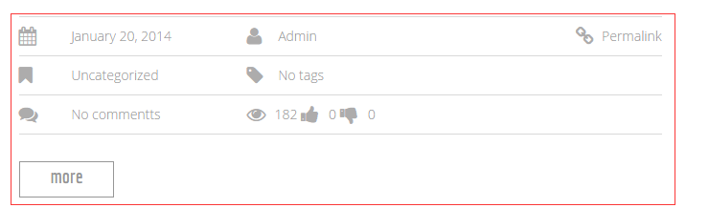

-红框里的内容不要。

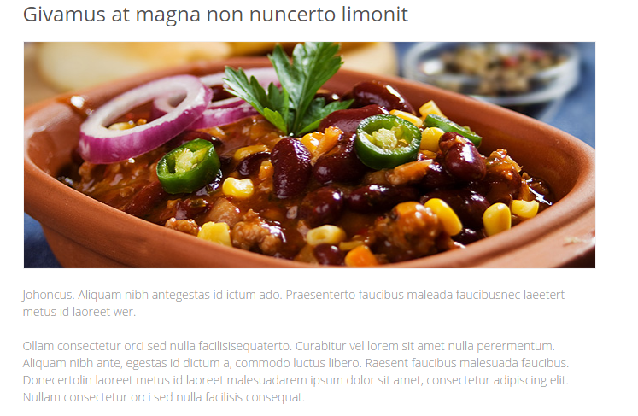

-把Givamus at magna non nuncerto limonit改为：HRD(Human Resource Director)

-把图18改为图18a

-把文章改为下面的

Main job duties:  
1. Personnel management, including staff recruitment, acceptance, promotions, resignation.  
2. Draw up instructions for all the posts.  
3. Attendance management.  
4. Working out the performance appraisal and how to implement it.  
5. The releasement of the payment and welfare.  
6. The job training for the staff, making monthly training and other training plans and putting them into implement and feed back of the result.  
7. The personnel secondary records management.  
8. Serving as the administrative assistance as part of their job. Including document management.,  
taking in and releasing the documents, textual materials reports, documents subscription and so on.



-红框里的内容不要。

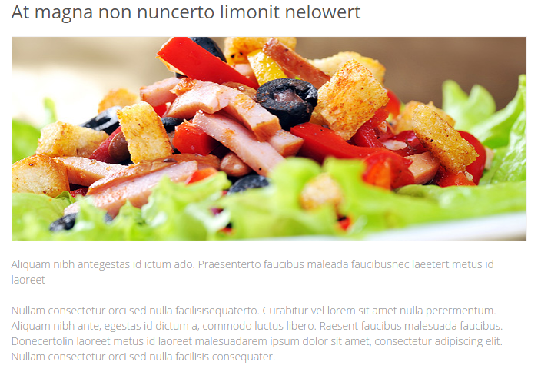

-把At magna non nuncerto limonit nelowert改为：CFO (Chief Financial Officer)

-把图19改为图19a

-把文章改为下面的  
Main job duties:

- Independently deal with the daily accounting of costing & inventory;

- Timely prepare internal management reports: majoring for inventory management and manufacturing costing, contribution margin analysis, inventory movement and aging reports;

- Arrange inventory physical counts to ensure the validity and accuracy of assets (i.e. month-end cycle counts or annual full stocktaking);

- Prepare quarter-end / year-end schedule reports; be familiar with Corporate HFM system and financial system reporting;

- Familiar with costing and inventory flow in manufacturing environment in order to assist to reinforce internal control practices and processes to comply with statutory and corporate requirements (US SOX Compliance: costing & inventory);

- Assist to setup new manufacturing system and financial system;

- Assist supervisor in ad hoc financial projects and management analysis reports.

- Work independently and with cross functional teams to collaborate on operation process improvements and effectively communicate operation requirements.



-红框里的内容不要

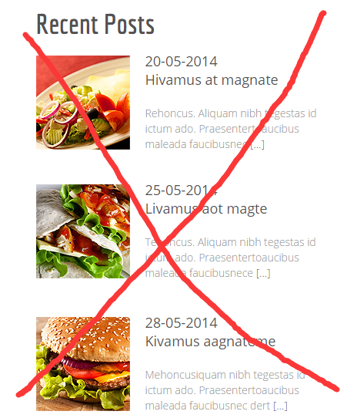

这个内容删除掉。

第五页：contacts

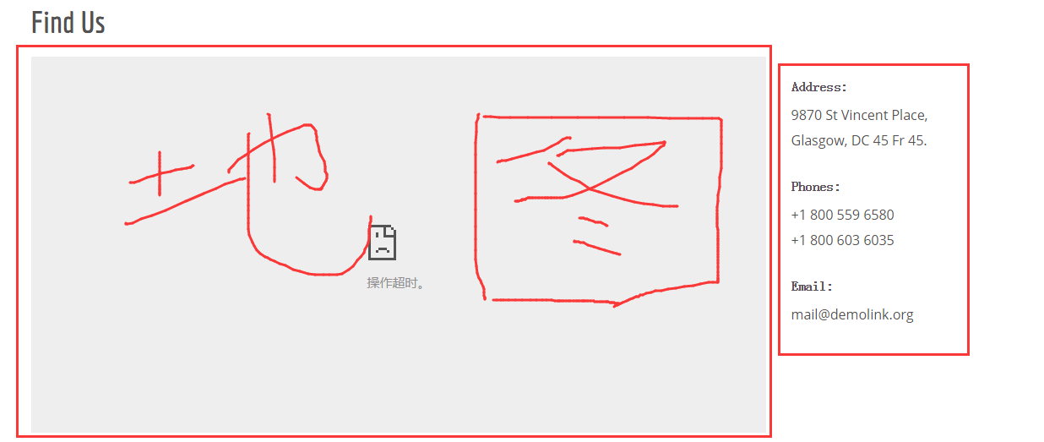

-把左边的地图改为图20。

-Address: Room 1204 Bldg 2 No.775 SiPing Road Shanghai China 200092

Phones:+86-21-61841205

Fax:+86-21-61841206

Moblie:+86 138 1626 4911

+86 136 3663 6840

Email: [singelly@outlook.com](mailto:singelly@outlook.com) [klausqiu@outlook.com](mailto:klausqiu@outlook.com)

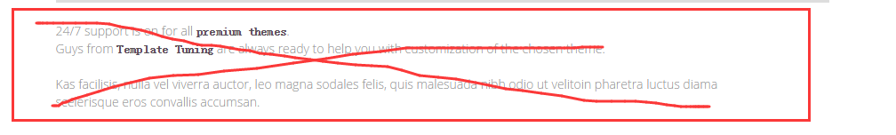

-这个内容删除掉。

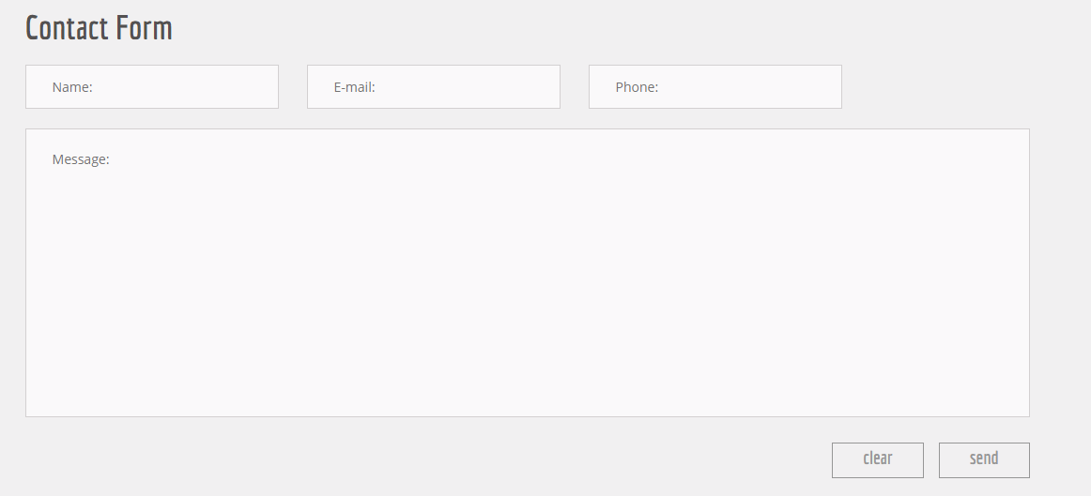

-上面这个保存不变。